Home [News](https://chennaiyinfc.com/press-releases/) [THE CLUB](https://chennaiyinfc.com/about-us/) [CONTACT US](https://chennaiyinfc.com/contact-us/)

WELCOME TO THE HOME OF CHENNAIYIN FC

## 

Chennaiyin FC

Chennaiyin Football Club is an Indian professional football club based in Chennai, Tamil Nadu. The club competes in the Indian Super League, the top flight of Indian football. The club was founded in August 2014 during the inaugural season of the Indian Super League.One of the successful club in the history of the league.The club has won the Indian Super League title on two occasions, in the 2015 and 2017–18 seasons respectively.

Taking a step forward this Pongal before our clash against Hyderabad FC

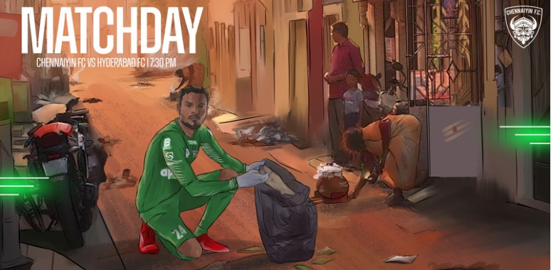Pongal is here! Beautiful Kolam, delicious Pongal, friends and family come together as we bid thanks. Of course we celebrate. But our celebrations usually come at a price. Not for us now. But for us later. And for municipality workers the price is now. For the environment too. As we rid ourselves of everything old and celebrate everything new, we forget about the heaps we light up in that bonfire. On the streets. In public places. Plastic and non-biodegradable waste plagues the city for days to come. “According to the Corporation officials, the quantity of waste generated from city beaches was close to 26 tonnes this year. "

#### CHENNAIN FC SQUAD 2021-2022

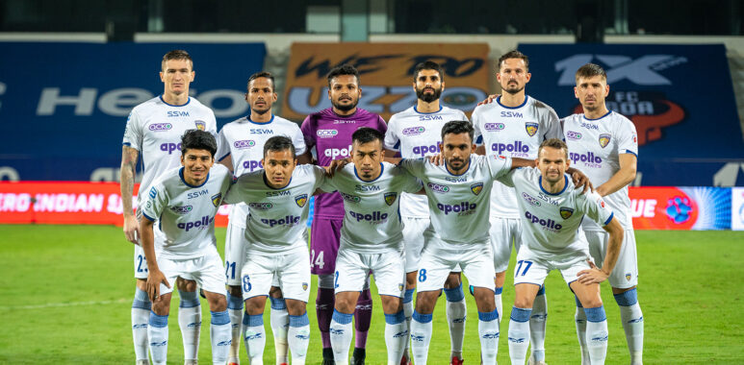

1. VISHAL KAITH
2. EDWIN SYDNEY VANSPAUL
3. LALLIANZUALA CHHANGTE
4. MIRLAN MURZAEV
5. VLADIMIR KOMAN
6. GERMANPREET SINGH
7. NINTHOINGANBA MEETEI
8. RAFAEL CRIVELLARO
9. ANIRUDH THAPA
10. NERIJUS VALSKIS
11. RAHIM ALI
12. JOBBY JUSTIN
13. NARAYAN DAS
14. SLAVKO DAMJANOVIC
15. BALAJI GANESAN

Hero ISL 2021/22 : FC Goa 1 vs 0 Chennaiyin FC

##### 

CHENNAIYIN FC SIGN NERIJUS VALSKIS UNTIL END OF SEASON

Goa, 31 December, 2021: Chennaiyin FC are delighted to announce that an agreement with Nerijus Valskis on a free transfer has been completed. The Lithuanian forward joins the club for the remainder of the season. “I am very excited and very happy to be back home and wear the blue shirt again,” said the forward. In his debut season in the Indian Super League (2019/20), Valskis won the golden boot, scoring 15 goals and providing 6 assists in 20 games to take Chennaiyin FC to the final. “Although the loss of Rafael was a hard one to take, we are extremely delighted to have Valskis join our ranks once again. We all know as Chennayin FC fans, of what he is capable of in our kit. I think his signing will empower us for the remainder of the season,” Chennaiyin FC co-owner Vita Dani said. After moving to Jamshedpur FC the season after, the Lithuanian has netted 10 goals in a season and a half for the club from Jharkhand.

DONE BY M.HARDEEP 2021UIT1107

hardeep.it21@bitsathy.ac.in